**21ème TOURNOI DU PAYS DU VELAY ORGANISE PAR LE CBBCHL(43)**

* + 1. **LES 04 ET 05 Juin 2022**

**BULLETIN DINSCRIPTION (aucune inscription ne sera prise en compte sans son règlement**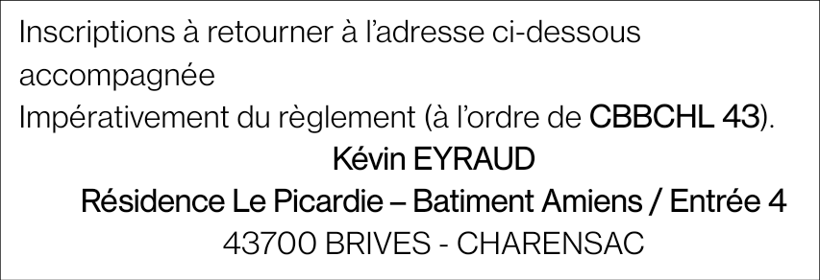

| Nom | Prénom | | H/F | Licence | Classement | | | Série demandée | | | | Partenaire de double | | Partenaire de mixte | |  | Prix tournoi |
| --- | --- | --- | --- | --- | --- | --- | --- | --- | --- | --- | --- | --- | --- | --- | --- | --- | --- |
| S | D | Mx | S | D | Mx | | Nom Prénom | Club | Nom Prénom | Club |
|  |  | |  |  |  |  |  |  |  |  |  |  |  |  |  |  |  |
|  |  | |  |  |  |  |  |  |  |  |  |  |  |  |  |  |
|  |  | |  |  |  |  |  |  |  |  |  |  |  |  |  |  |
|  |  | |  |  |  |  |  |  |  |  |  |  |  |  |  |  |
|  |  | |  |  |  |  |  |  |  |  |  |  |  |  |  |  |
|  |  | |  |  |  |  |  |  |  |  |  |  |  |  |  |  |
|  |  | |  |  |  |  |  |  |  |  |  |  |  |  |  |  |
|  |  | |  |  |  |  |  |  |  |  |  |  |  |  |  |  |
|  |  | |  |  |  |  |  |  |  |  |  |  |  |  |  |  |
|  |  | |  |  |  |  |  |  |  |  |  |  |  |  |  |  |
|  |  | |  |  |  |  |  |  |  |  |  |  |  |  |  |  |
|  |  | |  |  |  |  |  |  |  |  |  |  |  |  |  |  |
|  |  | |  |  |  |  |  |  |  |  |  |  |  |  |  |  |
|  |  | |  |  |  |  |  |  |  |  |  |  |  |  |  |  |
|  |  | |  |  |  |  |  |  |  |  |  |  |  |  |  |  |
|  |  | |  |  |  |  |  |  |  |  |  |  |  |  |  |  |
|  |  | |  |  |  |  |  |  |  |  |  |  |  |  |  |  |
| **TOTAL A PAYER** |  | **Total tournoi : (…… .x 17) + (……… x 20) + (………………. X 21) = ………..** | | | | | | | | | | | | | | | |